Methods and Compositions for
Permanent Lesion Site Identification

TECHNICAL FIELD

- The disclosure generally describes methods, compositions, devices and kits that provide for a system which can accurately mark an area of interest with regards to a lesion in order to facilitate future observation and monitoring of the size and shape of the lesion, to identify the area where a prior biopsy or excision of a lesion had occurred or to facilitate the orientation and to direct medical therapies such as radiation or heat.

BACKGROUND
- Misidentification of surgical sites may result in severe consequences including misdirected treatment with radiation, poor interspecialty communication, and lack of obtaining surgical objectives including incomplete tumor removal. The most common solution to biopsy site misidentification is preoperative photography. However, even with this protocol, wrong-site surgery still occurs since tissue can change before a follow up appointment. Other solutions include permanent visible markings on the body of the patient, but this is cosmetically undesirable to the patient, especially in highly visible areas.
Thus, an unmet need exists for a permanent, but selectively visible means of marking biopsy sites.
SUMMARY
- The presently disclosed methods, compositions and devices provide for a system which can accurately mark an area of interest with regards to a lesion in order to facilitate future observation and monitoring of the size and shape of the lesion, to identify the area where a prior biopsy or excision of a lesion had occurred or to facilitate the orientation and to direct medical therapies such as radiation or heat.
- In some embodiments, provides are methods for identifying a lesion site for future reference, wherein said method comprises: determining the diameter of the lesion and applicable margins; placing a template containing holes over the intended lesion; tattooing the skin using said holes of the template as a guide, wherein said tattooing comprises the use of an ink that is not readily visible in white light. In further embodiments these methods are used to identify a surgical site for post-surgical reference information. In other embodiments are methods for monitoring the size of a lesion of interest. In some embodiments are methods for accurately identifying a biopsy site and monitoring the size of the lesion of interest. In other embodiments are methods for identifying an excision site the lesion. In still other embodiments these methods provide for the identification and guidance of therapies, such as but not limited to radiation therapies. In some additional embodiments, these methods further comprise centering the template over the lesion of interest. In a preferred embodiment, the ink is visible under ultra-violet (UV) light but not white light. Therefore, in some embodiments, the ink is a UV fluorescent ink. In some embodiments the ink is in a disposable sterile cartridge and in some aspects the cartridge also includes a needle.
- Also provided herein is a kit for use in the methods described herein. In some embodiments the kit comprises: a removable template with holes; a tattoo device comprising a needle and a power source; an ink cartridge containing an ink that that is not readily visible in white light. In other embodiments the kit further comprises instructions for use. In additional embodiments such kits further comprise a non-white light source under which said ink is visible. In some embodiments the non-white light source is mounted on said tattoo device. In some embodiments this non-white light source is UV light and the ink is UV UV-fluorescent ink.

BRIEF DESCRIPTION OF THE DRAWINGS

- FIGURE 1 provides an example of a stencil.

- FIGURE 2 is a model of a biopsy site prior to excision of biopsy specimen.

- FIGURE 3 is a model of a biopsy specimen.

- FIGURE 4 a model of biopsy site after specimen excision.

- FIGURE 5 illustrates the absorbance spectrum of the coumarin micelles.

- FIGURE 6 illustrates the average diameter and distribution of the coumarin micelles.

- FIGURE 7 Diagram representation of a fluorescent pigment. The fluorescent pigment is made of coumarin-doped poly(methyl methacrylate) (PMMA) microparticles. This pigment will later be dispersed within our ink formulation.

- FIGURE 8 Schematic of the needle and ink cartridge.

- FIGURE 9 Effect of tip diameter on ink storage. An ANOVA test was performed on the first set of data and returned p=0.0013, indicating there is significant statistical evidence to conclude larger diameter tips stored more ink. A t-test was performed on the second set of data and returned p=0.1067, indicating there is some statistical evidence that supports the conclusion that a shorter base stores more ink.

- FIGURE 10 illustrates the effect of base height on ink storage. A t-test was performed on the second set of data and returned p=0.1067, indicating there is some statistical evidence that supports the conclusion that a shorter base stores more ink.

DETAILED DESCRIPTION
DEFINITIONS
- In this disclosure, the use of the singular includes the plural, the word “a” or “an” means “at least one”, and the use of “or” means “and/or”, unless specifically stated otherwise. Furthermore, the use of the term “including”, as well as other forms, such as “includes” and “included”, is not limiting. Also, terms such as “element” or “component” encompass both elements and components comprising one unit and elements or components that comprise more than one unit unless specifically stated otherwise.
- The section headings used herein are for organizational purposes only and are not to be construed as limiting the subject matter described. All documents, or portions of documents, cited in this application, including, but not limited to, patents, patent applications, articles, books, and treatises, are hereby expressly incorporated herein by reference in their entirety for any purpose. In the event that one or more of the incorporated literature and similar materials defines a term in a manner that contradicts the definition of that term in this application, this application controls.
- As used herein, “patient” or “subject” includes mammalian organisms which are capable of undergoing surgical procedures, such as but not limited to biopsy or tumor excision procedures, as described herein, such as human and non-human mammals, for example, but not limited to, rodents, mice, rats, non-human primates, companion animals such as dogs and cats as well as livestock, e.g., sheep, cow, horse, etc.
- As used herein, and unless otherwise indicated, the terms “treat,” “treating,” “treatment” and “therapy” contemplate surgical and therapeutic medical procedures, such as but not limited to observing and monitoring the size of a lesion, biopsy of a lesion, excision of a lesion, and spatial orientation to direct therapies such as radiation or heat.
- One of the most common yet preventable forms of medical malpractice is wrong-site surgery. Misidentification of surgical sites can result in severe consequences including misdirected treatment with radiation, poor practitioner inter-specialty communication, and a failure to obtain surgical objectives including, among others incomplete tumor removal. Currently the most common solution to biopsy site misidentification is preoperative photography. However, even with this protocol, wrong-site surgery still occurs since tissue can change before a follow up appointment. Other solutions include permanent visible markings on the body of the patient, but this is cosmetically undesirable to the patient, especially in highly visible areas. Thus, a longstanding need exists for a permanent, but selectively visible means of marking a biopsy site that is not disfiguring.
- Embodiments of the present disclosure include the use of ink that is visible only under specified stimulated states, and thus undesirable cosmetic effects are eliminated. Also provided are systems and methods that include symbols and patterns that effectively communicate applicable information between the specialist and the pathologist.
- The presently disclosed methods, compositions and devices provide for a system which can accurately mark an area of interest with regards to a lesion in order to facilitate future observation and monitoring of the size and shape of the lesion, to identify the area where a prior biopsy or excision of a lesion had occurred or to facilitate the orientation and to direct medical therapies such as radiation or heat.
- In some embodiments of the present disclosure, methods for identifying a lesion site (and/or another site such as a surgical site) for future reference are disclosed. In an embodiment, a method comprises: determining the diameter of the lesion and applicable margins; placing a template containing holes over the intended lesion; tattooing the skin using said holes of the template as a guide, wherein said tattooing comprises the use of an ink that is not readily visible in white light. In further embodiments these methods are used to identify a surgical site for post-surgical reference information. In other embodiments are methods for monitoring the size of a lesion of interest. In some embodiments are methods for accurately identifying a biopsy site and monitoring the size of the lesion of interest. In other embodiments are methods for identifying an excision site the lesion. In still other embodiments these methods provide for the identification and guidance of therapies, such as but not limited to radiation therapies. In some additional embodiments, these methods further comprise centering the template over the lesion of interest. In a preferred embodiment, the ink is visible under ultra-violet (UV) light but not white light. Therefore, in some embodiments, the ink is a UV fluorescent ink. In some embodiments the ink is in a disposable sterile cartridge and in some aspects the cartridge also includes a needle.
- Also provided herein is a kit for use in the methods described herein. In some embodiments the kit comprises: a removable template with holes; a tattoo device comprising a needle and a power source; an ink cartridge containing an ink that that is not readily visible in white light. In other embodiments the kit further comprises instructions for use. In additional embodiments such kits further comprise a non-white light source under which said ink is visible. In some embodiments the non-white light source is mounted on said tattoo device. In some embodiments this non-white light source is UV light and the ink is UV UV-fluorescent ink.
- In some embodiments, the presently disclosed methods, compositions and devices facilitate the identification of tissue extraction site following excision, a removable template is utilized to orient future practitioners with regards to an excision site, as well as to orient excised tissue samples relative to the site of excision. Thus allowing the practitioner to accurately identify an excision site post-surgically at some time in the future. In some embodiments, to avoid undesirable cosmetic effects these methods utilize ink that is visible only under a specified stimulated state (for example, UV light). In some embodiments, the method of marking biopsies with a system of symbols or patterns that are intuitive, practitioner - friendly and effectively communicate applicable information between the surgical specialist and the pathologist.
- In some embodiments, components are provided in a kit for use in the present methods and said kits comprise a tattoo machine with a needle, a rechargeable battery, and an ink cartridge. In some aspects the needle is disposable; in others the ink cartridge is disposable. In additional aspects the ink comprises ultraviolet (UV) fluorophores in an inert shell, for example micro or nanoparticles that are suspended in a liquid phase. In some embodiments, the method employs a disposable, sterile cartridge containing the needle and ink that is attached to a reusable, battery-operated tattoo device for use in marking the biopsy site with UV-fluorescent ink. In some embodiments are methods for synthesizing the biocompatible, UV- fluorescent ink.

METHOD OF MARKING -TEMPLATE
- One aspect of the disclosed invention is a template stencil which provides a standardized method of conveying orientation information on a specimen that is easily interpreted and which causes minimal tissue damage. In some embodiments, provided herein is a method of marking is provided wherein a stenciling template design where circles of different diameters are available. A single template of determined diameter will be needed per biopsy, but all sizes are available in order to accommodate the varying lesion size (and/or another site such as a surgical site). In some aspects, each template stencil is designed as a pair of concentric circles, each with holes dispersed around the circumference (Fig 1). Along the inner ring, there is a 3-corner identification system that encodes orientation information, which serves to facilitate communication between physician and pathologist (Fig 1). In additional aspects, the stencil also has a defined opening at the center of the stencil to allow for proper alignment of the stencil over the center of the lesion (and/or another site such as a surgical site). The stencil provides consistency in the tattooing of the template as well as ease of use and interpretation by others, for example, a pathologist.
- In some embodiments, the methods, compositions and devices are provided in a kit that can be used to identify biopsy location post-operatively on the patient and to identify the specimen, biopsy margins, and orientation information on the extracted tissue. In some aspects, a standard patterning method that inflicts minimal tissue damage and is easy to interpret may be preferred.
- In some embodiments, the invention features methods and compositions used to permanently mark human tissue for identification of specific sites at later dates. In other embodiments, the methods are used to mark biopsy sites or sites of surgical excision, or to mark field positioning for radiation treatments. In some aspects, the outermost circle is a circumferential tattoo that permanently identifies the biopsy site on the patient at a later date. Since the tattoo remains on the patient following the biopsy in order to alleviate follow up complications and site discrepancies. In some aspects, the innermost circle, includes 3- corner identification notches indicates the tattoo that is excised with the tissue during the biopsy procedure and provides position identification to a pathologist who is examining the sample. A model of the biopsy site with the tattoo patterning method before and after excision of the tissue is shown in Fig 2, Fig 3, and Fig 4.
- In some embodiments, the tattoo patterning method is configured to be understood by a health care practitioner who identifies and interprets lesions (and/or other surgical sites), such as a doctor. In some embodiments, the patterning method is used to topographically indicate the orientation of the biopsy site. For example, the triangle shape is solely reserved for the side of the lesion that follows the previously defined “superior” orientation, square for “anterior”, etc. In some embodiments, the stencil uses the 3-corner identification system to incorporate orientation and other relevant information within the tattoo. The stencil allows this to be done without excessive markings or a high level of skill in tattoo artistry. The preferred stencil design is flexible enough to accommodate all areas of the skin and adhesive enough to remain attached to the area of interest while the tattoo procedure is performed. In some embodiments, the stencil comprises waterproof adhesive, is disposable. In some embodiments the stencil is pulled from an adhesive sheet containing stencils of various diameters, utilizing the pattern and hole distribution to mark the biopsy site. In some aspects, the stencil is disposed of following the procedure. There are many advanced adhesives for medical applications that can be used.

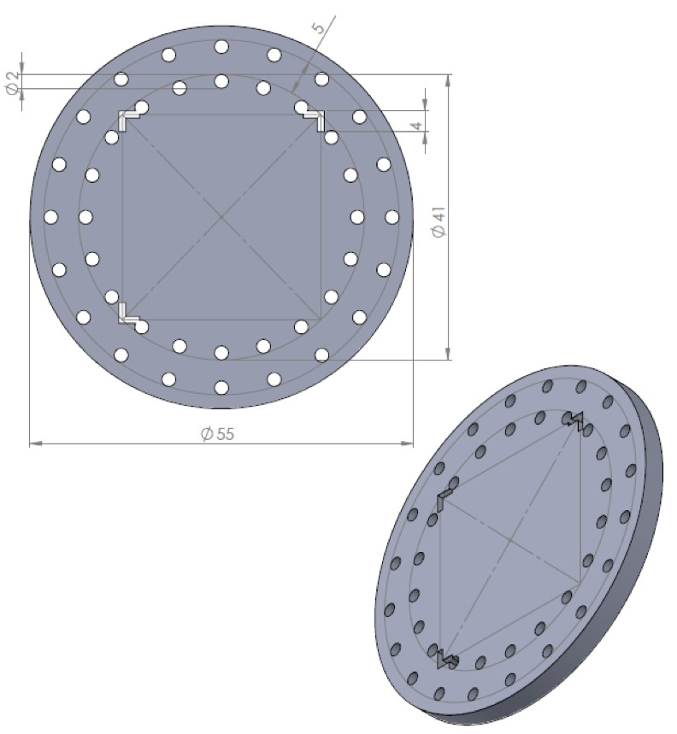
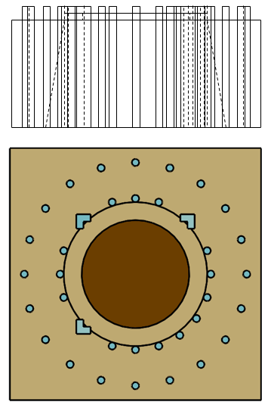
Figure 1: Model of stencil with units of millimeters (mm)

Figure 2: Model of biopsy site prior to specimen excision. Dark, circular region represents the lesion.

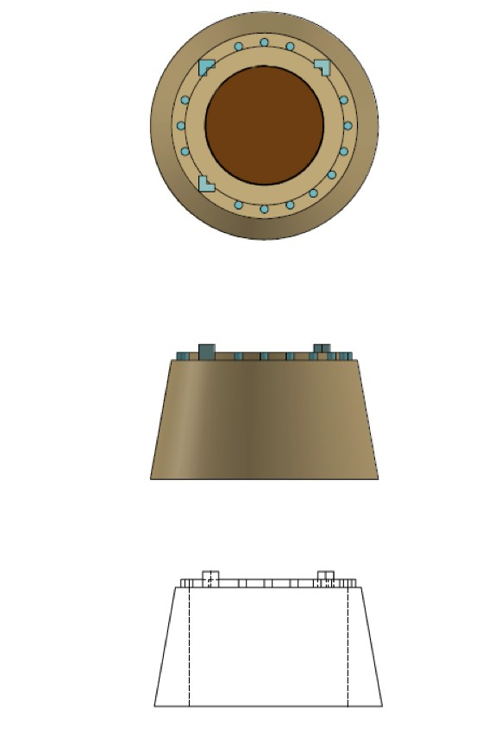
v
Figure 3: Model of biopsy specimen

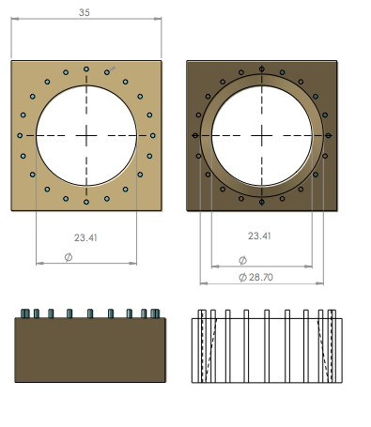
Figure 4: Model of biopsy site after specimen excision. Units are in millimeters (mm).

- In some embodiments, the patterning protocol combines two aspects of the tattooing procedures: one for tattooing of the specimen for biopsy purposes and the other for tattooing the residual biopsy site for identification at a later date. In some embodiments, the patterning protocol includes: determining the diameter of the lesion plus margins for biopsy; selecting a stencil sticker (adhesive template) of appropriate size based on the previously determined diameter; wiping the skin with alcohol and allowing it to air dry; marking the center of the lesion with a marker; using the hole at the center of the stencil to properly align the stencil with the center of the lesion; and placing the stencil sticker on the skin over the center of the lesion; using a three-corner identification system to orient the missing corner with the inferior, lateral position of the patient’s body assuming the following orientation:
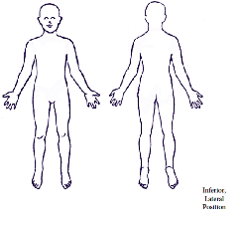

- Covering the body of the tattoo device with plastic to maintain the sterility of the device; loading a new cartridge into the tattoo device, wherein the cartridge contains the needle and the UV-fluorescent ink; turning on the tattoo device to tattoo the skin using the holes of the stencil as a guide while lightly pressing the tattoo device into the patient’s skin to ensure proper ink deposition; using the Wood’s lamp or black light provided to ensure the tattoo appears even and complete. In some embodiments the Wood’s lamp is incorporated into the device, diming the overhead lights during the procedure may ensure correct patterning, after ensuring the tattoo is of optimal quality, the stencil sticker may be removed and discarded. In a further aspect, cutting slightly outside of the innermost circle while staying within the outer circle while illuminating the tattoo under the Wood’s lamp or black light, once the biopsy specimen has been excised the circumferential tattoo is utilized on the specimen to ensure the base of the specimen is wider than the top. The specimen is sent to pathology and the pathologist will be able to use the 3-corner identification system to determine the orientation of the lesion and tissue biopsied. At the end of the procedure, the plastic covering the body of the tattoo device and the cartridge can be disposed of in the appropriate waste container. The body of the tattoo device is disinfected and the tattoo device is then returned to its charging station prior to next use.
- In alternative embodiments, the patterning method uses a machine-readable Quick Response (QR) code identification system and pertinent patient information lies embedded within the two-dimensional matrix.
BIOCOMPATIBLE SELECTIVELY VISIBLE INK
- Another aspect of the present disclosure includes a non-toxic biocompatible and photo stable dye or ink which provides a permanent, but selectively visible, means of marking lesion sites (and/or another site such as a surgical site). This may be referred to as a selectively visible ink. In some embodiments, a selectively visible ink may comprise a UV-fluorescent pigment. In some embodiments the selectively visible ink formulation utilizes coumarin as the fluorescent compound. As an organic, hydrophobic, well characterized and readily available molecule, coumarin serves as a molecule that fluoresces in the ideal UV spectra.
- In some embodiments, the ink formulation is on the microscale, inert and biocompatible. In some embodiments the ink formulation includes but is not limited to fluorescent compounds and pigment vehicles, microspheres, microcapsules, micro particles, and liposomes. In some embodiments, the ink formulation comprises coumarin micelles which absorb light at a max of 320 nm (range approximately 300-370 nm: Fig 5). Coumarin micelle diameters are approximately 100 nm or larger.
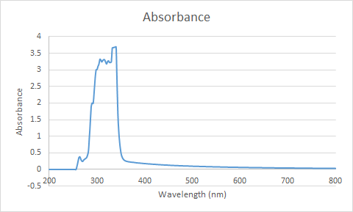

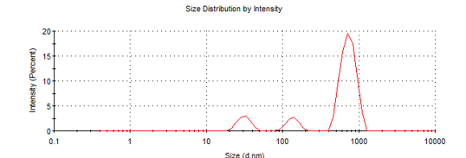
Figure 5: Absorbance spectrum of the coumarin micelles

Figure 6: Average diameter and distribution of the coumarin micelles

- In some embodiments, the coumarin is embedded within poly(methyl methacrylate) (PMMA) microspheres. PMMA is an inert, biocompatible, and transparent low cost biomaterial. In some embodiments, the coumarin-PMMA pigment contains about 98% PMMA and 2% coumarin. The coumarin-PMMA pigment will be about 5% of the total ink formulation, which also contains water, glycerol for maintaining viscosity, polysorbate 80 as an emulsifier, benzyl alcohol as a preservative, and simethicone as an anti-foaming agent (Fig 7).

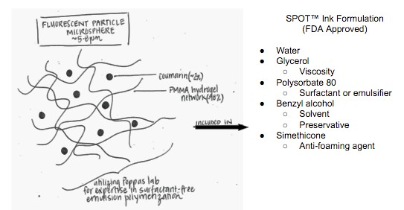

Figure 7

- In other embodiments, the ink formulation comprises silicone crystal nanomaterials. In some aspects, the nanobeads are surrounded in silica dioxide and are inert and biocompatible. In other embodiments, the ink formulation comprises quantum dots. Quantum dots can demonstrate a very high quantum yield even in low quantities. These particles can be embedded deeply into the skin, leading to potentially long lasting photo stabile deposition.
TATTOO DEVICE
- Another aspect of the disclosed subject matter is a tattoo device which preferably is lightweight, cordless and which is easy to clean, sanitize or sterilize. The tattoo device may include and/or be configured to detachably couple with one or more needles (such as 3 round needles) for deposition of selectively visible ink. In some embodiments, each needle may be “pre-dipped” in ink, which includes non-toxic biocompatible and photo stable dye or ink which provides a permanent, but selectively visible, means of marking lesion sites (and/or another site such as a surgical site). In some embodiments, the patterning protocol combines two aspects of the tattooing procedures: one for tattooing of the specimen for biopsy purposes and the other to mark lesion site (and/or another site such as a surgical site) for further observation. In some embodiments such a tattoo device has a control system housed within the body of the device and electrically coupled to the motor and power supply for actuation of the needle.
- In some embodiments, selectively visible tattoo inks can be encapsulated in coumarin or a similar fluorescent molecules in poly(methyl methacrylate) and similar polymeric particles. In regards to lesion site identification (and/or surgical site identification), the selectively visible tattoo inks may permanently mark human tissue for identification of specific sites at later dates. In some aspects the tattoo device has a disposable cartridge containing biocompatible UV ink and a needle. In some aspects the ink also meets several of its design targets. In some embodiments, coumarin is a useful fluorescent particle, as it is readily available and in the correct excitability spectrum. Although such a pigment itself is toxic, formulation with PMMA renders the ink biocompatible and non-toxic.
- In some embodiments the tattoo device is lightweight, cordless with a rechargeable battery and it is easy to clean and sterilize. In some aspects consumable needles may be used and in other aspects the deposition of ink involves 3 round needles. In some embodiments, the tattoo device uses a drive unit, such as a rotary motor to drive the needle axle, which provides a design that is noticeably quieter and produces less severe vibrations than another embodiment of the drive unit, such as a magnetic coil motor. In some embodiments, the tattoo device may utilize a 3-5 V DC input voltage and generates approximately 5,800 vertical oscillations (i.e. reciprocations) per minute in the needle axle with an amplitude of approximately 2 mm. In some embodiments the power supply includes one or more rechargeable batteries and circuitry that provide inductive charging. In some aspects the power supply includes at least one of a rechargeable nickel cadmium battery and/or lithium ion battery, where the rechargeable batteries have a defined voltage and capacity, such as approximately 4.1 volts (V) and a capacity of 700 milliamp hours (mAh). Nickel cadmium batteries have a long lifetime, low self- discharge rate, and are relatively low in cost as compared to other types such as nickel metal hydride and lithium ion. In some aspects the power circuit is selectively controlled by the user using a switch. In some embodiments, a magnetic coil induction charger allows the battery to be charged by inducing a charging current from the alternating current (such as 120 V 60 Hz) supplied by the opposite terminal of the charger. When such a device is not in use, the device can be stored on a stand that contains the charger. For example, a single operating cycle may provide an estimated 2.8 hours of use. In some embodiments, the motor and power supply are very user friendly and require minimal involvement by the user, they are cordless, lightweight (78 g), inexpensive ($52), and also have a long lifetime (at least 2 years). Based on existing tattoo industry standards on sterility dictate the use of materials that are either single-use or sterile-packaged and autoclavable. In alternative embodiments a tattoo device may be completely isolated from the subject and sanitized between uses.
- An exemplary embodiment of a cartridge (referred to also as an ink cartridge) for the application of the needle and ink to the tattoo device is described in Fig 8. In some aspects, ink is stored in the inkwell (9), which is formed from the threaded closure (7) between the threaded surfaces of the cartridge cap (8) and pen tip (5). A rubber gasket (6) ensures a watertight seal. The pen tip includes a disc plate (2) that is constrained by support posts (4) to restrict vertical motion. The needle (3) is press fit into the disc plate with rubber tubing (1), which also serves as the attachment to the needle axle. Thumb grips (10) making it easier to remove the cap. The needle (3) is at least partially disposed in a needle annulus formed by the pen tip (5) and axially disposed along central axis (11). It is understood that the rubber tubing (1) may be embodied more generally as a tubular structure that couples to the needle (3) and a needle axle of the tattoo device. This may allow for the creation of a force path along central axis (11) between the needle axle and the needle (3) such that the needle (3) can reciprocate during operation in order to deposit the selectively visible ink into the dermis of the patient.
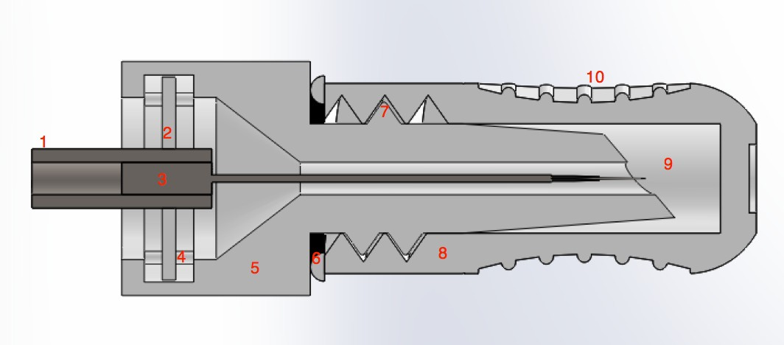

11

12

Figure 8: Schematic of the needle and ink cartridge
- In some embodiments, a removable seal is used on the left opening of the pen tip (3) while packaged (i.e., a seal over the opening formed by the pen tip at an end distal to the end of the pen tip in the inkwell). Exemplary dimensions of the cartridge with several versions of varying dimensions were tested. The results of these tests are summarized below (Fig 9).

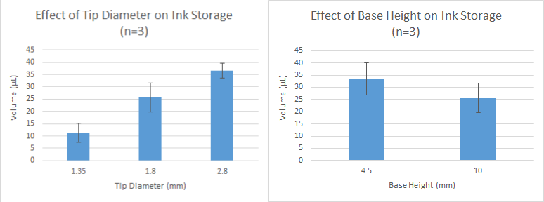

Figures 9 & 10:

- In some embodiments the needle extends beyond the pen tip by a fixed distance equal to the deposition depth. The required deposition depth depends on variables influencing the thickness of individual skin layers with the upper dermis (0.5 - 2.0 mm deep) being the target location for tattoo ink. In some embodiments needle cartridges are produced with varying deposition depths, which would be selected by the practitioner. In some aspects the entire cartridge is disposable and can therefore be sterilized and packaged individually. In some aspects, the usable volume of selectively visible ink stored in the cartridge is at least 37 microliters which is sufficient for moderate sized tattoos using the selectively visible ink, and large or complex patterns could be completed with additional cartridges if necessary.
- In some embodiments the tattoo device comprises a control system for needle actuation by a motor, where the control system is disposed within an external body (occasionally referred to as a body member), and a power source for the motor (occasionally referred to as a drive unit). In some embodiments, the needle tip which enters the skin, may utilize an ink capsule or internal ink reservoir for ink deposition driven by capillary action.
- In certain aspects of the present disclosure, the actuation method of the needle includes use of a drive unit such as but is not limited to, at least one of a magnetic coil, a pneumatic, or a rotary motor. While magnetic coil tattoo devices may offer nuanced control of the needle for the tattoo artist, known versions of these pens can be noisy and bulky. Alternatively, pneumatic pens require a source of pressurized air. Thus, embodiments of the present disclosure may implement a drive unit that is rotary motor as it is less complex and quietest of these options.
- In certain other aspects, the source of power for the motor includes, but, is not limited to an external power supply or a battery as an internal power supply system. In some embodiments, such batteries can be rechargeable or disposable. In an embodiment, the needle and ink are contained in a single cartridge. Alternative embodiments include having the ink and cartridge independent of one another. It should be noted that a traditional tattoo artist’s pen requires that the needle be dipped into an ink well repeatedly during application.
- In some embodiments, the body of the tattoo device has a pen tip that is pre-dipped in ink, so the practitioner has a constant supply of ink for the necessary markings. This tip contains the maximum amount of ink need for the design. In one embodiment, the tattoo device is cordless, portable, quiet, and has a rechargeable battery, which lasts about 2.8 hours of constant usage, depending on the amount of usage. One such a tattoo device is capable of tattooing and utilizing a recharge stand for the battery.
KITS
- In some embodiments, for ease of use practitioners may prefer to receive a kit comprising all items necessary to carry out the described methods. In some embodiments, a kit may comprise: a removable template with holes; a tattoo device comprising a needle and a power source; an ink cartridge containing an ink that that is not readily visible in white light, such as those described herein and one such ink is a UV-fluorescent ink that is visible ultra-violet light. Such kits can be single use in totality or only certain aspects may be single use, such as but not limited to templates, ink or needles, which can be available in single use sealed sterile packaging. In some embodiments, such kits may furthermore contain instructions to guide practitioners in their use. In some embodiments, a instruction sheet that outlines the procedural steps of the methods set forth herein, and will follow substantially the same procedures as described herein or are known to those of ordinary skill in the art. The instruction information may be in a computer readable media containing machine-readable instructions that, when executed using a computer, cause the display of a real or virtual procedure of performing the methods described herein.
- Another example of a specific embodiment of a kit may comprise: a flexible template comprising a plurality of openings; a tattoo device comprising a drive unit, a power supply, and a control circuit; and one or more ink cartridges. Embodiments of an ink cartridge may comprise a pen tip, a needle, and a cartridge cap. A cartridge cap may have interior walls that define an inkwell, where at least a portion of interior walls comprise a threaded surface. The inkwell comprises a selectively visible ink, such as embodiments of the inks disclosed herein. The cartridge cap may also include a pen tip having one end at least partially disposed within the inkwell. In some embodiments, a cartridge cap may comprise one or more thumb grooves, which comprise detents having an array of frictionally engagable ridges. The pen tip may have a threaded surface that is engaged with the threaded surface of the cartridge cap. The pen tip may also be configured to define a needle annulus extending axially along the central axis and having a diameter that is larger than the outer diameter of a needle disposed therein. The cartridge cap may also comprise one or more needles, with each needle axially disposed along the central axis. A needle may have a hollow tube at least partially disposed within the needle annulus and at least partially extending a defined distance past at least a portion of the pen tip into the inkwell, such as between approximately 0.5 mm to 2.0 mm outside of the needle annulus. The pen tip also includes a second end that is distal to another end of the pen tip that is disposed within the cartridge cap. The second end may be configured to concentrically retain a disc plate and restrict axial movement of the disc plate relative to the pen tip. The disc plate may form an opening that is axially aligned with the needle annulus such the needle is at least partially disposed through the opening of the disc plate. The needle at least partially extends a defined distance outside of the needle annulus into the inkwell. The selectively visible ink may be in a liquid phase, and thus while the needle may be exposed to the ink in the inkwell while it is in the liquid phase. The hollow tube of the needle may comprise a defined amount of the selectively visible ink that is retained within the inkwell. In some embodiments, the defined amount of selectively visible ink comprised within the hollow tube of the needle is at least thirty seven milliliters.
- In some embodiments of the kit, a tubular structure is also included. The tubular structure (such as a tube made of rubber or other rigid material suitable for creating a force path) may be axially disposed through the opening of the disc plate and at least a portion of the needle is fitted within the tubular structure along the central axis. The tubular structure may be configured to create a force path along the central axis between the needle axle of the tattoo device and the needle.
- In some embodiments of the present disclosure, operation of a kit may include the practitioner removing the ink cartridge from the kit, removing a seal from the ink cartridge to expose the needle and/or tubular structure attached to the needle, and attaching the needle axle of the tattoo device to the ink cartridge, such as via the tubular structure. The practitioner may then remove the cartridge cap and prepare the patient for the marking process. The practitioner may then align the template over the lesion site (and/or another site such as a surgical site), align the pen tip over one of the opening of the template, and proceed to mark (i.e., tattoo) the dermis of the patient using the ink comprised within the needle, such as the selectively visible ink discussed herein.
- An example of the specific embodiment of a kit is presented at the top of the following Table and a specific embodiment of an ink suitable for use with an ink cartridge disclosed herein includes a UV-fluorescent ink in the bottom half of the table. It is understood that a UV-fluorescent ink may be one embodiment of a selectively visible ink.
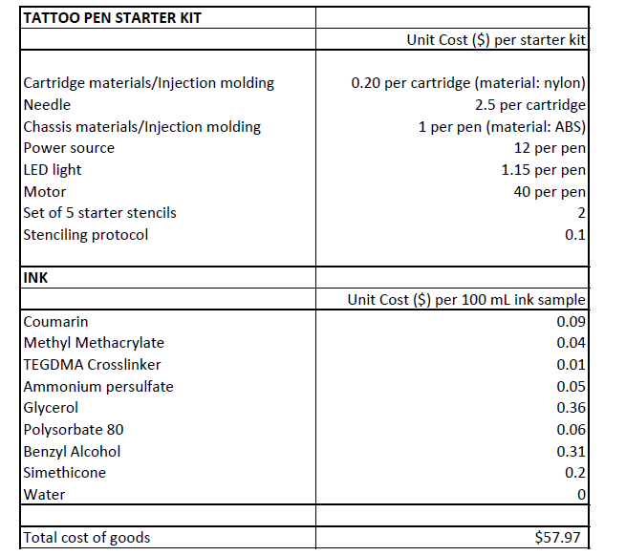

REFERENCES
- The following literature citations as well as those cited above are incorporated by reference.
- 1. Kethu, S. R., Banerjee, S., Desilets, D., Diehl, D. L., Farraye, F. A., Kaul, V., Kwon, R. S., Mamula, P., Pedrosa, M. C., Rodriguez, S.A., Wong Kee Song, L.M., and Tierney, W.M., 2010, “Endoscopic Tattooing,” Gastrointestinal Endoscopy, 72(4), pp. 681-685.
- 2. Ke, M., Moul, D., Camouse, M., Avram, M., Carranza, D., Soriano, T., and Lask, G., 2010, “Where Is It? The Utility of Biopsy-Site Photography”, Dermatologic Surgery, 36(2), pp.198 - 202.
- 3. Xiao, L., “Tattoo Needle Tip With Capillary Ink Reservoir and Combined Device Thereof,” W.O. Patent 2015/154649, October 15, 2015.
- 4. Xiao, L., “Tattoo Needle Tip Equipped with Capillary Ink Reservoir, Tattoo Tube Having Handle and Said Tattoo Needle Tip, and Assembly of Said Tattoo Needle Tip and Tattoo Needle,” U.S. Patent 2013/0226211, August 29, 2013.
- 5. Hickman, C. B., III, “Medical Mapping Device,” U.S. Patent 2008/0287978, November 20, 2008.
- 6. Fischer, W., Deckers, A., Guntherberg, N. , Jahns, E., Haremza, W., and Schmidt, H., “Crosslinked Polymer Particles Containing a Fluorescent Dye, ” U.S. Patent 5,710,197, January 20, 1998.
- 7. Hahn, E., Ostertag, W., and Seybold, G., “Fluorescent Pigments, ” U.S. Patent 5,470,502, November 28, 1995.
- 8. Carroll, G. H., “Photochromatic Tattoo,” U.S. Patent 6,470,891, October 29, 2002.
- 9. Anderson, R. R., Mlynarczyk-Evans, S. K., and Drill, C. A., “Permanent, Removable Tissue Markings,” U.S. Patent 7,285, 364, October 23, 2007.
- 10. Klitzman, B. and Koger, K. E., “Tattoo Inks,” U.S Patent 6,013,122, January 11, 2000.
- 11. Smolinski, M. C., “Tattooing Method for Radiation Therapy,” W. O. Patent 2008/074052, June 26, 2008.
- 12. Chuang, G. S. and Gilchrest, “Labeled Skin Lesion Biopsy Punch and Uses Thereof,” U.S. Patent 2012/0238906, September 20, 2012.
- 13. Stolle C.J., Harvey T.B., Korgel B.A., 2013, “Nanocrystal Photovoltaics: A Review of Recent Progress,” Current Opinion in Chemical Engineering, 2(2), pp. 160-167.
- 14. Warner J. H., Hoshino A., Yamamoto K., Tilley R.D., 2005, “Water-soluble photoluminescent silicon quantum dots,” Angewandte Chemie International Edition, 44 (29), pp. 4550-4.
- 15. He Y., Zhong Y.L., Peng F., Wei X.P., Su Y.Y., Lu Y.M., Su S., Gu W., Liao L.S., Lee S.T., 2011, “Biomimetic Preparation and Dual-Color Bioimaging of Fluorescent Silicon Nanoparticles”; Journal of the American Chemical Society, 133, pp. 14192.
- 16. Bosma G., Pathmamanoharan C., de Hoog E. H. A., Kegel W. K., van Blaaderen A., Lekkerkerker H. N. W.; 2002; “Preparation of monodisperse, fluorescent PMMA-latex colloids by dispersion polymerization.” Journal of Colloid and Interface Science. 245: 292– 300.
- 17. Hyman N., Waye, J.D.; 1991; “Endoscopic four quadrant tattoo for the identification of colonic lesions at surgery.” Gastrointestinal Endoscopy. 37: 56-8.
- 18. Tyco Electronics. Comparison of NiCd, NiMH, and Li-Ion Batteries. March 2016, https://www.portal.state.pa.us/portal/server.pt/document/1219030/ecr-5892d_nicd_nimh_li-ion_pdf_(2)
- 19. Brio Smart Clean Sonic Toothbrush Manual.
- 20. Roberta Pryor, CTS. Austin Plastic Surgery Institute. Interviewed December 2, 2015.
- 21. Emergo Group, Annual Medical Device Industry Survey, January 2013, http://www.emergogroup.com/research/annual-medical-device-industry-survey.
- 22. Starling, J. Turn the Other Cheek. December 2015, https://psnet.ahrq.gov/webmm/case/265/turn-the-other-cheek#references
- 23. Etzkorn, J. R. and Rosen, A., 2015, “Biopsy Site Photography Reduces Surgical Delay, “Identifies Potential Wrong-site Surgery, and Increases Patient Confidence in Treatment,” American Society for Dermatologic Surgery 2015 Annual Meeting Oral Abstracts, pp. 99.
- 24. The Johns Hopkins Hospital. Estimated Average Charges for Common Procedures. Marc 2016, http://www.hopkinsmedicine.org/the_johns_hopkins_hospital/_docs/jhh_charges.pdf
- 25. Paul, S. P., 2015, “Errors in Surgical Site Identification during Cutaneous Surgery for Skin Cancer: Review and Recommendations,” Surgical Science, 6, pp. 327-335.
- 26. Chuang, G. S. and Gilchrest, B. A., 2012, “Ultraviolet-fluorescent Tattoo Location of Cutaneous Biopsy Site,” Dermatological Surgery, 38(6), pp. 479-83.
- 27. David, J. E., Castle, S. K. B., and Mossi, M. K., 2006, "Localization Tattoos: An Alternative Method Using Fluorescent Inks," Radiation Therapist, 15(1), pp. 1-5.
- Without further elaboration, it is believed that one skilled in the art can, using the description herein, utilize the present methods to its fullest extent. The embodiments described herein are to be construed as illustrative and not as constraining the remainder of the disclosure in any way whatsoever. While preferred embodiments have been shown and described, many variations and modifications thereof can be made by one skilled in the art without departing from the spirit and teachings of the presently disclosed methods. Accordingly, the scope of protection is not limited by the description set out above, but is only limited by the claims, including all equivalents of the subject matter of the claims. The disclosures of all patents, patent applications and publications cited herein are hereby incorporated herein by reference, to the extent that they are consistent with the present disclosure set forth herein.

CLAIMS
What is claimed is:
- A method for identifying a lesion site or surgical site for future reference, wherein said method comprises:
determining the dimensions of the lesion and applicable margins or surgical site;
placing a template containing holes or markings over the intended lesion;
tattooing the skin using said holes or markings of the template as a guide,
wherein said tattooing comprises the use of an ink that is not readily visible in white light.
- The method of claim 1, wherein it is a method for identifying a surgical site for post-surgical reference.
- The method of claim 1, wherein it is a method for monitoring the size of a lesion.
- The method of claim 1, wherein it is a method for identifying a biopsy site and monitoring the size of the lesion.
- The method of claim 1, wherein it is a method for identifying an excision site of the lesion.
- The method of claim 1, wherein it is a method for identifying and guiding radiation therapy.
- The method of claims 1, wherein said template is centered over the intended lesion.
- The methods of claim 1-8, wherein said ink is visible under ultra-violet (UV) light
- The methods of claims 1-9, wherein said ink is a UV-fluorescent ink.
- The methods of claim 1-10, wherein said ink is in a disposable, sterile cartridge.
- The method of claim 11, wherein said cartridge also includes a needle.
- A system of identifying a surgical site for post-surgical reference, comprising the use of the methods of claims 1-12.

- A kit for use in the methods of claims 1-12, said kit comprising:
a removable template with holes;
a tattoo device comprising a needle and a power source;
an ink cartridge containing an ink that that is not readily visible in white light.

- The kit of claim 14, further comprising instructions for use.
- The kit of claims 14, further comprising a non-white light source under which said ink is visible.
- The kit of claim 15, wherein said light source is mounted on said tattoo device.
- The kit of claim 14, wherein said light source generates ultra-violet light and wherein said ink is UV-fluorescent ink.

18. A system for identifying a lesion site or surgical site for future reference, the system comprising:
a flexible template that defines a plurality of openings having at least some of the plurality of openings concentrically disposed about a center of the template;
a tattoo device comprising:
a body member extending along a central axis,
a drive unit at least partially disposed within the body member, wherein the drive unit is operatively coupled to a needle axle and configured such that the needle axle is reciprocable along the central axis; and
an ink cartridge that detachably couples to the tattoo device, the ink cartridge comprising:
a cartridge cap having interior walls that define an inkwell, wherein at least a portion of interior walls comprise a threaded surface, wherein the inkwell comprises a selectively visible ink,
a pen tip having one end at least partially disposed within the inkwell and threadably engaged with the threaded surface of the cartridge cap, the pen tip defining a needle annulus extending axially along the central axis,
a needle axially disposed along the central axis and having a hollow tube disposed within the needle annulus.

19. The system of claim 18, wherein each of the plurality of openings of the flexible template are configured to fitably engage with a pen tip coupled to a tattoo device.

20. The system of claims 18 and 19, wherein the cartridge cap comprises one or more detents having an array of frictionally engagable ridges.

21. The system of claims 18-20, wherein the selectively visible ink is in a liquid phase.

22. The system of claims 18-21, wherein the pen tip includes a second end that is configured to concentrically retain a disc plate and restrict axial movement of the disc plate relative to the pen tip, the disc plate forming an opening axially aligned with the needle annulus.

23. The system of claim 22, wherein the needle is at least partially disposed through the opening of the disc plate.

24. The system of claims 1-23, wherein one end of the needle at least partially extends a defined distance outside of the needle annulus into the inkwell.

25. The system of claims 1-24, wherein the hollow tube comprises a defined amount of the selectively visible ink that is retained within the inkwell.

26. The system of claims 18-25, wherein the defined amount of selectively visible ink comprised within the hollow tube of the needle is at least thirty seven milliliters.

27. The system of claims 22-26, further comprising a tubular structure axially disposed through the opening of the disc plate, wherein at least a portion of the needle is fitted within the tubular structure along the central axis, wherein the tubular structure is configured to create a force path along the central axis between the needle axle of the tattoo device and the needle.

28. An ink cartridge comprising:
a cartridge cap having interior walls that define an inkwell, wherein at least a portion of interior walls comprise a threaded surface, wherein the inkwell comprises a selectively visible ink,
a pen tip having one end at least partially disposed within the inkwell and threadably engaged with the threaded surface of the cartridge cap, the pen tip defining a needle annulus extending axially along the central axis, ,
a needle axially disposed along the central axis, the needle having a hollow tube at least partially disposed within the needle annulus and at least partially extending past at least a portion of the pen tip into the inkwell.

29. The ink cartridge of claim 28, wherein the cartridge cap comprises one or more detents having an array of frictionally engagable ridges.

30. The ink cartridge of claims 29, wherein the selectively visible ink is in a liquid phase.

31. The system of claims 28-30, wherein the pen tip includes a second end that is configured to concentrically retain a disc plate and restrict axial movement of the disc plate relative to the pen tip, the disc plate forming an opening axially aligned with the needle annulus

32. The system of claim 31, wherein the needle is at least partially disposed through the opening of the disc plate.

33. The system of claims 28-32, wherein one end of the needle at least partially extends a defined distance outside of the needle annulus into the inkwell

34. The system of claims 28-33, wherein the hollow tube comprises a defined amount of the selectively visible ink that is retained within the inkwell

35. The system of claims 28-34, wherein the defined amount of selectively visible ink comprised within the hollow tube of the needle is at least thirty seven milliliters.

37. The system of claims 31-35, further comprising a tubular structure axially disposed through the opening of the disc plate, wherein at least a portion of the needle is fitted within the tubular structure along the central axis, wherein the tubular structure is configured to create a force path along the central axis between the needle axle of the tattoo device and the needle.
ABSTRACT
Described are methods, compositions, devices and kits that provide for a system which can accurately mark an area of interest with regards to a lesion in order to facilitate future observation and monitoring of the size and shape of the lesion, to identify the area where a prior biopsy or excision of a lesion had occurred or to facilitate the orientation and to direct medical therapies such as radiation or heat.

